Stand: 16.11.06
DER Kopier-Roboter
Datenabgleich und Backup - RoboCopy ist DAS TOOL für solche unverzichtbaren Aufgaben
In den Windows Server 2003 Resource Kit Tools befindet sich das kostenlose Kommandozeilen-Tool Robocopy.exe.
Damit hat man den absoluten Spezialist für alle Belange der Datensynchronisation (Backup). Mit 72 Schaltern erledigt das Tool selbst ungewöhnliche Aufgaben extrem schnell und informativ.
Robocopy läuft unter Win NT4, 2000 und XP.
--------------------------------------------------------------------------------
The Microsoft® Windows® Server 2003 Resource Kit Tools are a set of tools to help administrators streamline management tasks such as troubleshooting operating system issues, managing Active Directory®, configuring networking and security features, and automating application deployment.
File Name: rktools.exe
Download Size: 12049 KB
Date Published: 4/28/2003
Version: 2003
Download: http://www.microsoft.com/downloads/details.aspx?familyid=9d467a69-57ff-4ae7-96ee-b18c4790cffd&displaylang=en
--------------------------------------------------------------------------------
Wer nun nicht das ganze Resource Kit herunterladen und installieren will, der muss diese beiden Dateien
RoboCopy.exe
RoboCopy.doc
aus unserem Downloadbereich holen und in den system32-Ordner kopieren, denn unter Win2000 lässt sich das Resource Kit nicht installieren.
Download: http://www.msu-hb.de/download/robocopy.exe und http://www.msu-hb.de/download/robocopy.doc
Beispiele:
1. Anhand des einfachen Eintrags unter Start > Ausführen: robocopy c:\daten g:\backup\daten /MIR wird schnell deutlich, wie mächtig RoboCopy ist. Hiermit werden z.B. veraltete Daten auf dem Ziel (g:\backup\daten) ersetzt, fehlende ergänzt und überzählige Dateien und Ordner gelöscht.
Mit dem zusätzlichen Schalter /MON - robocopy c:\daten g:\backup\daten /MIR /MON:5 - läuft RoboCopy in einer Endlosschleife und schreibt die betroffenen Dateien auf das Backup, sobald fünf (5) Änderungen unter C:\Daten stattgefunden haben. dabei ist der Ressourcenverbrauch dieser Hintergrundaktion gering. Beendet wird die Schleife mit [STRG+C].
2. Sollen nur überzählige Dateien gelöscht werden, verwenden wir statt /MIR die Schalter /S /PURGE.
- /S berücksichtigt alle Unterordner
- /PURGE veranlasst das Löschen
3. Will man nur die Wirkung eines Befehls vor der Ausführung prüfen, muss jede Schalterkombination durch /L ergänzt werden. damit zeigt das Tool exakt an, was es im Ernstfall täte.
- Der Schalter /L eignet sich auch für eine Datei-Übersicht mit Datums- u. Größenangaben > robocopy c:\daten b:\ /S /MAXAGE:20 /MIN:5000000 /L /NDL
Hierauf zeigt das Programm alle Dateien in c:\daten und allen Unterordnern, die in den letzten 20 Tagen entstanden sind und mehr als 5 MB umfassen.
- Der Schalter /NDL unterdrückt die durchlaufenen Verzeichnisse und verbessert somit die Übersicht.
- b:\ ist ein Dummy-Zielordner - er existiert nicht.
4. Genial: Auf Multi-Boot-Systemen mit WinXP u. Win2000 lassen sich hervorragend 1:1-Kopien des jeweiligen anderen Systems erstellen.
- Beispiel: robocopy c:\*.* g:\backup\win2000 /MIR
- auf c:\ liegt Win2000 und wird nun von d:\ - hier liegt XP - auf g:\backup\win2000 gesichert.
Die in den Beispielen benutzten Schalter sind in der nachstehenden Syntax-Tabelle rot gekennzeichnet.
Wichtig: Immer erst den Quellordner und danach das Ziel eingeben.
RoboCopy verwendet diesen General-Syntax:
RoboCopy | Resource Kit Copy-Tool
robocopy Source Destination [File [File]..] [/S | /E] [/LEV:n] [/Z] [/B] [/ZB] [/COPY:Copy_Flags] [/SEC] [/COPYALL] [/NOCOPY] [/PURGE] [/MIR] [/MOV] [/MOVE] [/CREATE] [/FAT] [/FFT] [/256] [/MON:n] [/MOT:m] [/A+:{R | A | S | H | N}] [/A-:{R | A | S | H | N}] [/RH:hhmm-hhmm] [/PF] [/IPG:ms] [/A] [/M] [/IA:{R | A | S | H | N | C | E}] [/XA:{R | A | S | H | N | C | E}] [/XF ExFile [ExFile]..] [/XD Directory [Directory]..] [{/XC|/XN|/XO}] [{/XX|/XL}] [/IS] [/IT] [/MAX:bytes] [/MIN:bytes] [/MAXAGE:{days | YYYYMMDD}] [/MINAGE:{days | YYYYMMDD}] [/MAXLAD:{days | YYYYMMDD}] [/MINLAD:{days | YYYYMMDD}] [/ITEM] [/IOFF] [/XJ] [/R:RetryNumber] [/W:WaitTime] [/REG] [/TBD] [/L] [/X] [/V] [/TS] [/FP] [/NS] [/NC] [/NFL] [/NDL] [/NP] [/ETA] [/LOG:file_name] [/LOG+:file_name] [/TEE] [/JOB:job_name] [/SAVE:job_name] [/QUIT] [/NOSD] [/NODD] [/IF] [/SD:path] [/SD:path] [/?]
Parameter | Erklärung
Syntax: robocopy | Source Destination [File [File]..]
Source (Quelle) | Specifies the source directory. Source can use the Universal Naming Convention (UNC) format ("\\myserver") or reference a local drive
Destination (Ziel) | Specifies the destination directory. Destination can use the Universal Naming Convention (UNC) format ("\\myserver") or reference a local drive
File | Specifies the file or files to copy. Wildcard characters can also be used. *.* is the default value of File. It specifies all files in the directory specified by Source
/S | Copies all subdirectories, excluding empty ones
/E | Copies all subdirectories, including empty ones
/LEV:n | Copies only the top n levels of the source directory tree. n indicates the number of levels
/Z | Copies files in restartable mode
/B | Copy files in Backup mode. Copying files in backup mode is not restartable. Backup mode may be able to copy files that restartable mode cannot....
/ZB | Use restartable mode; if access is denied, use backup mode
/COPY:Copy_Flag | The /COPY: parameter copies specified file properties. The default is /COPY:DAT Flag Description  D File data  A File attributes  T File time time stamps  S File security. This attribute copies the NTFS Access Control Lists (ACL).  O File ownership. This attribute copies the NTFS file ownership information.  U File auditing. This attribute copies the NTFS file auditing information.
Note | Source and destination volumes must both be NTFS to copy Security, Ownership or Auditing information.
/SEC | Copy files with security. Equivalent to /COPY:DATS.  /COPYALL  Copy all file attributes. Equivalent to /COPY:DATSOU.
/NOCOPY | Does not copy any file attributes.
/PURGE | Deletes destination files and directories that no longer exist in the source directory.
/MIR | Mirror a directory tree. The equivalent of /E /PURGE.
/MOV | Moves files, deleting the source after copying to the destination.
/MOVE | Moves files and directories, deleting the source after copying to the destination.
/A+:{R | A | S | H | N} | Adds the given attributes to copied files. The following table lists the valid attributes: Attribute Description  R Read only  S System  A Archive  H Hidden  N Not content indexed
/CREATE | Create directory tree and zero-length files only.
/FAT | Creates destination files using 8.3 FAT file names only.
/FFT | Assume FAT File Times (2-second interval). Useful for copying to third-party systems that declare a volume to be NTFS but only implement file times with a 2-second interval.
/256 | Turn off very long path support. Very long path names are those longer than 256 characters
/MON:n | Monitors the source for change. The n parameter specifies the number of changes allowed in the source. If this number is exceeded, processing restarts.
/MOT:m | Monitors the source for change. The m parameter specifies the number of minutes to wait before checking for changes. If there are changes, processing restarts.
/RH:hhmm-hhmm | Defines the time slot during which starting new copies is allowed. Useful for restricting copies to certain times of the day. Both values must be 24–hour times in the range 0000 to 2359.
/PF | Makes more frequent checks to see if starting new copies is allowed (per file rather than per pass). Useful in stopping copy activity more promptly at the end of the run hours time slot.
/IPG:ms | Inter-Packet Gap in milliseconds. This parameter is used to free bandwidth on slow network links
/A | Copies only files with the archive attribute set.
/M | Copies only files with the archive attribute set, but removes the archive attribute from source files.
/IA:{R | A | S | H | N | C | E} | Includes only files with any of the given Attributes set. The following table lists the valid attributes: Attribute Description  R Read only  A Archive  S System  H Hidden  N Not content indexed  C Compressed  E Encrypted
/XA:{R | A | S | H | N | C | E} | Excludes files with any of the given attributes. The following table lists the valid attributes: Attribute Description  R Read only  A Archive  S System  H Hidden  N Not content indexed  C Compressed  E Encrypted
/XF ExFile | Excludes files matching given names, paths, or wildcard characters.
/XD Directory | Excludes directories matching given names/paths.
/XC | Excludes changed files.
/XN | Excludes newer files.
/XO | Excludes older files.
/XX | Excludes extra files and directories.
/XL | Excludes lonely files and directories.
/IS | Includes same files.
/IT | Include files tagged as tweaked.
/MAX:bytes | Excludes files larger than specified.
/MIN:bytes | Excludes files smaller than specified.
/MAXAGE:{days | YYYYMMDD} | Excludes files with a Last Modified Date older than n days or specified date. If n is less than 1900, then n is expressed in days. Otherwise, n is a date expressed as YYYYMMDD.
/MINAGE:{days | YYYYMMDD} | Excludes files with a Last Modified Date newer than n days or specified date. If n is less than 1900, then n is expressed in days. Otherwise, n is a date expressed as YYYYMMDD.
/MAXLAD:{days | YYYYMMDD} | Excludes files with a Last Access Date older than n days or specified date. If n is less than 1900, then n is expressed in days. Otherwise, n is a date expressed as YYYYMMDD.
/MINLAD:{days | YYYYMMDD} | Excludes files with a Last Access Date newer than n days or specified date. If n is less than 1900, then n is expressed in days. Otherwise, n is a date expressed as YYYYMMDD.
/IOFF | Includes Offline files. Excluded by default.
/ITEM | Includes Temporary files. Excluded by default.
/IOFF | Includes Offline files. Excluded by default.
/XJ | Excludes Junction points.
/R:RetryNumber | Specifies the number of retries on failed copies. The default value of RetryNumber is 1 million.
/W:WaitTime | Specifies the wait time between retries. The default value for WaitTime is 30 seconds.
/REG | Saves /R:RetryNumber and /W:WaitTime in the Registry as default settings.
/TBD | Waits for sharenames to be defined (retry error 67).
/L | Lists files without copying, time stamping, or deleting any files.
/X | Reports all extra files, not just those selected.
/V | Produces verbose output, showing skipped files.
/TS | Include source file time stamp in the output.
/FP | Include full path in the output.
/NS | Excludes the file size from the log file.
/NC | Excludes the file class from the log file.
/NFL | Excludes the file names from the log file.
/NDL | Excludes the directory names from the log file.
/NP | Suppresses progress display.
/ETA | Displays estimated time of arrival for copied files.
/LOG:file_name | Writes status to a log file. If the file exists, it is overwritten.
/LOG+:file_name | Writes status to a log file. If the file already exists, the status is appended to it.
/TEE | Displays output in the console window, in addition to directing it to the log file specified by /LOG or /LOG+.
/JOB:job_name | Gets parameters from the job file.
/SAVE:job_name | Saves parameters to the job file
/QUIT | Quits after processing the command line. No files will be copied. Use /QUIT with /JOB to view job file contents.
/NOSD | Declares that no source directory is specified. Useful in template Jobs for which the source is provided at run time.
/NODD | Declares that no destination directory is specified. Useful in template Jobs for which the destination is provided at run time.
/IF | Includes files with the specified names, paths, or wildcard characters. Intended for use in Job files only.
/SD:path | Explicitly specifies the source directory for the copy. Intended for use in Job files only.
/? | Displays command-line usage.
RoboCopy mit Copyrite = grafisch
Wer RoboCopy lieber über eine grafische Oberfläche als über die Kommandozeile bedienen möchte, der kann dazu das kostenlose Tool Copyrite (englisch) verwenden. Das Prog gibt es für WinXP, W2K, Win98 u. WinServer2003.
Download:
Die neue kostenpflichtige Version gibt es hier:
http://copyrite.dynu.com/index.htm
Die ältere Version - wie auf der HP beschrieben - steht hier zum Download:
http://www.msu-hb.de/download/critexp.zip
Die Dateien RoboCopy.exe u. RoboCopy.doc müssen ins CopyRite-Verzeichnis kopiert werden. Dann lassen sich damit auch die Sicherungsmaßnahmen weitestgehend automatisieren und Batchdateien erstellen.
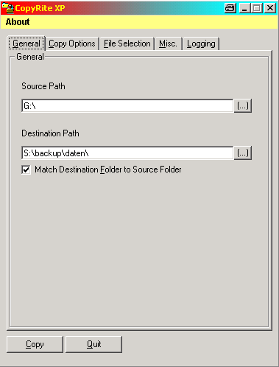 | 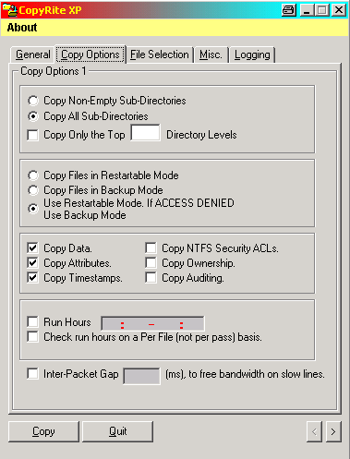
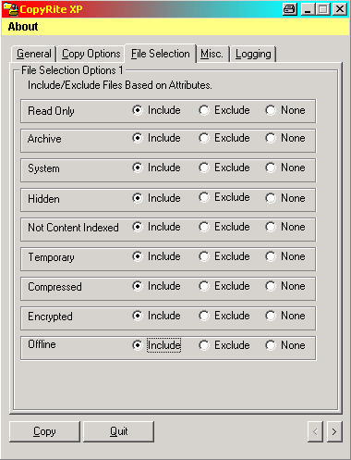 | 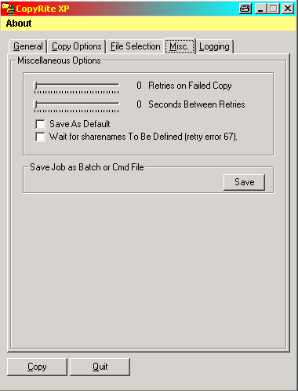
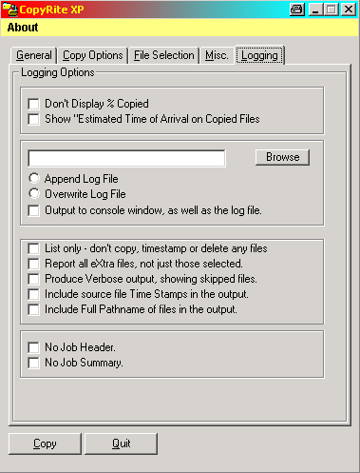 | 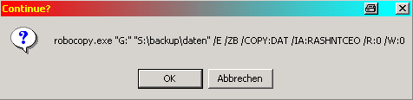

Es ist auschliesslich die Option /ZB, die die Schwierigkeiten verursacht... Lässt man die weg, geht es.
Allerdings wird dann auch der als "normaler User" erstellte Backup-Ordner als schreibgeschützter Systemordner erstellt.

