Eingeschränkte oder keine Konnektivität -Workaround-

- Update 27.05.2005 -
So oder ähnlich kann die Fehlermeldung respektive der Hinweis lauten, wenn das Servicepack 2 installiert wurde. Das Ganze wird durch ein kleines Warnsymbol im Systray noch zusätzlich gekennzeichnet.
Es handelt sich nur in seltenen Fällen um ein wirkliches Problem, denn meistens wird nur dezent darauf hingewiesen, daß eben nur ein bestimmter Teil der Netzwerkressourcen genutzt wird, ein Bug der sich mit dem Servicepack 2 eingeschlichen hat.
Aber es hat auch schon schwerwiegendere Fälle gegeben, wo keinerlei Verbindung mehr ins Netzwerk oder Internet möglich war.
Lösungsansatz 1:
Wenn Netzwerk und Internet einwandfrei funktionieren ist nur ein kosmetischer Eingriff nötig:
Start ->Einstellungen ->Systemsteuerung ->Netzwerkverbindungen ->hier klickt man mit der rechten Maustaste auf die LAN-Verbindung ->Eigenschaften und im sich öffnenden Fenster macht man den Haken bei "Benachrichtigen,wenn diese Verbindung eingeschränkte oder keine Konnektivität besitzt " raus ->fertig.
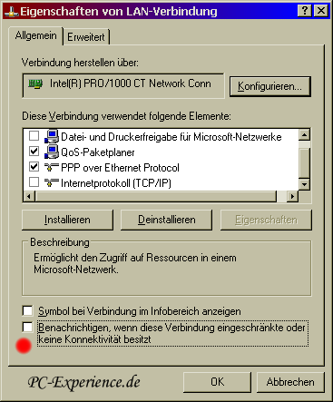

Lösungsansatz 2:
Start ->Einstellungen ->Netzwerkverbindungen ->LAN-Verbindung ->Eigenschaften ->Internetprotokoll ->eine feste IP-Adresse vergeben
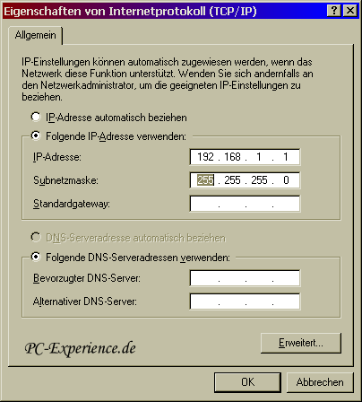

Lösungsansatz 3:
Wenn ein Router vorhanden ist sollte eine IP-Adresse außerhalb der Router-Range gewählt werden.
Lösungsansatz 4:
Wenn ihr euch als DSL User über RASPPPOE oder DFÜ ins Internet einwählt, benötigt ihr das TCP/IP Protokoll nicht und könnt den Haken dafür entfernen (aber nicht deinstallieren!).
(Ausnahme: Gateway- oder Proxy-Installation über Netzwerkkarte mit fest zugeteilter IP-Adresse und natürlich im Netzwerk).
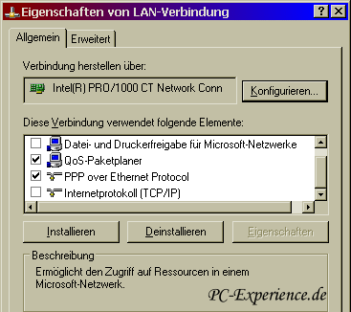

Lösungsansatz 5:
Es kann auch noch unterstützend wirken, wenn man über den Arbeitsplatz auf "Extras" klickt ->Ordneroptionen ->Ansicht und das Häkchen bei "Automatisch nach Netzwerkordnern und Druckern suchen" entfernt.
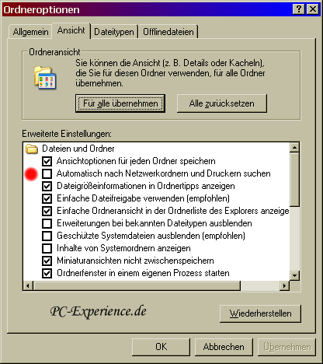

Lösungsansatz 6:
Sicherheitscenter deaktivieren und adäquate Virenscanner und Personal Firewalls verwenden: siehe Sicherheitsbug Datei-und Druckerfreigabe
Die Deaktivierung erfolgt über Start->Programme->Verwaltung->Dienste, dort nun mit der rechten Maustaste auf
"Windows-Firewall/Gemeinsame Nutzung der Internetverbindung".
Im Kontexmenü klickt man auf Eigenschaften und stellt den Starttyp von "Automatisch" auf Deaktiviert. Anschließend klicken wir noch auf "Dienststatus" "beenden" oder starten den Rechner neu.
Dasselbe gilt auch für den Dienst "Sicherheitscenter"!
Lösungsansatz 7:
Es kann Probleme in Verbindung mit W-LAN Netzwerkkarten (PrismGT) und der VT8237 Southbridge des entsprechenden Via Chipsatzes geben. In dem Fall bitte nach Treiberupdates Ausschau halten und in hartnäckigen Fällen die W-LAN Karte tauschen.
Lösungsansatz 8:

Fehlermeldung, wenn die WinSocks-Bibliothek oder TCP/IP beschädigt sind

Lösungsansatz 9:
Wenn ein übereifriger Virenscanner eure LSP-Kette beschädigt hat (wichtig für TCP/IP), dann existiert ein sehr gutes Tool, um dies zu reparieren:
LSP-Fix
Sollten sich weitere Lösungsansätze herauskristallisieren, so werden wir diesen Workaround aktualisieren.
LSP-Fix
Repairs Winsock 2 settings, caused by buggy or improperly-removed Internet software, that result in loss of Internet access
LSP-Fix is a free utility to repair a specific type of problem associated with certain Internet software. This type of software is known as a Layered Service Provider or LSP, a piece of software that can be inserted into the Windows TCP/IP handler like a link in a chain. However, due to bugs in the LSP software or deletion of the software, this chain can get broken, rendering the user unable to access the Internet.
Unfortunately, this type of software is sometimes quietly installed by unrelated software such as file-sharing programs, sneaking onto a system unannounced. In fact, in many cases, the user does not know of its existance until something goes wrong, and he/she can no longer access Web sites. Common offenders include New.net* (NEWDOTNET) and WebHancer*, which are often bundled with file-sharing utilities, DVD player software, and other free downloads. LSP-Fix repairs the Winsock LSP chain by removing the entries left behind when LSP software is removed by hand (or when errors in the software itself break the LSP chain), and removing any gaps in the chain.
LSP-Fix is not a malware removal utility and does not target specific products. LSP-Fix does not delete any files.

Downloads: (All downloads will fit easily on a floppy disk.)
- lspfix.zip - includes the program and documentation
If you are using the program on a machine that cannot open .zip files, or are downloading for a friend whom you're not sure can read .zip files, download the uncompressed files below instead. It will take a bit longer, but this way the program can be used as-is (e.g. from a floppy disk).
LSPFix.exe
lspfix.txt
Screen Shot
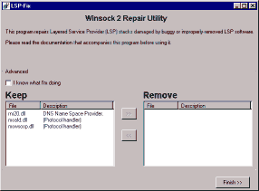

Third Party Winsock Repair Tools
Following is a list of additional LSP/Winsock repair utilities written by others. These are provided for convenience, and are not written or tech-supported by cexx.org. Please direct support inquiries at the original authors! Thanks.
http://members.shaw.ca/techcd/WinsockXPFix.exe - Winsock repair utility designed for Windows XP.
LSP-FIX - Winsock 2 repair utility
==================================

This program attempts to correct Internet connection problems resulting from buggy or improperly-removed Layered Service Provider (LSP) software. When you start LSP-Fix, it will read the list of LSP modules from the Windows registry and verify that each module is present. If a module is missing, it is placed on the "Remove" list for removal. Advanced users can override suggested removals in the "Advanced" area. When "Finish" is pressed, the undesired entries are removed, and the remaining entries in the registry are renumbered to make them consecutive. The total module counts are then updated. Finally, the program will display a summary of the changes that were made.

FOR THE CHANGES TO TAKE EFFECT, IT MAY BE NECESSARY TO RESTART YOUR COMPUTER. After restarting, connect to the Internet normally and try accessing a Web domain such as http://www.google.com to check that your connection is working properly. If you still cannot access Web sites, see the "Recovering From Disaster" section below for other possible fixes.

Since some errors result from misnumbered LSP entries rather than missing modules, the "Remove" list may be empty. Don't worry if this is the case; the misnumbered entries will be corrected when you press "Finish".

Please do not check the "I know what I'm doing" box unless you really know what you're doing. This option is for advanced users only and is not necessary to repair your system.

** IMPORTANT **
There is a known issue with using this software in combination with obsolete versions of Lavasoft's popular AD-Aware utility. A known issue in some versions of AD-Aware results in improper removal of pests such as New.Net, CommonName, and WebHancer, resulting in lost Internet access. If LSP-Fix is used subsequently to repair these errors, the system may begin exhibiting crashes in MSAFD.DLL and/or RPCSS. This can be fixed by performing a "hard restore" of Windows' networking components. This involves uninstalling the "Communications" item in Windows setup, deleting the Winsock2 registry key, and reinstalling Communications. http://support.earthlink.net/mu/1/psc/img/walkthroughs/windows_9x_nt/dialers/dun_1.3/5289.psc.html explains this procedure in detail.

If you have additional information about what this version of AD-Aware does to mess up Winsock, or have a system this has happened on that doesn't need to be repaired immediately, please email me: winsock "at" cexx.org so I can figure out what is going on and fix it. I have so far been unable to reproduce this issue, and consequently, unable to update LSP-Fix to deal with it.

Notes
-----
No changes will be made until you press the 'Finish' button. To exit without making any changes, simply close the program instead of pressing Finish.

It makes no difference which order the module entries appear in. LSP-Fix will retain the entries in the order that they appear in the Registry. (In other words, shuffling them around on the Keep/Remove lists has no effect.)

LSP-Fix is not a malware removal utility and does not target specific products. LSP-Fix does not delete any files.

Recovering From Disaster
------------------------
I make the assumption that your system actually does use Winsock 2 (all Win98 and higher do). If you are running Windows 95 and are not sure if Winsock 2 has been installed on your system, it should be re-installed. The file is available from the Microsoft Web site or (probably) windowsupdate.microsoft.com .

If the Winsock2 Registry keys are missing entirely (LSP-Fix returns an error) or damaged beyond repair, it will be necessary to restore them. A brief walkthrough of this procedure is available at http://cexx.org/winsock.htm .

Some LSP products may overwrite system files such as 'wsock32.dll'. If this has occurred, or you still cannot access Web sites, it may be necessary to re-install Winsock 2 (or Windows) to restore the original files.

Crashes in RPCSS or MSAFD: Please see the section marked **IMPORTANT** above (under "LSP-FIX - Winsock 2 repair utility") for an explanation of the problem and how to fix it.

Requirements
------------
Windows 95 with Winsock 2, Windows 98, Windows ME, Windows XP, or Windows 2000.

Other
-----
To provide a faster download, the LSP-Fix program is compressed using UPX, the Ultimate Packer of eXecutables. Please visit the UPX homepage at http://www.upx.org if you are interested in compressing your own software.

Butt Covering
-------------
This software is provided AS-IS, without any warranty of any kind, either express or implied. No lifeguard on duty. Registry Edit at your own risk.

Here come the all-caps. This means you should read it twice.

TO THE MAXIMUM EXTENT PERMITTED BY APPLICABLE LAW, IN NO EVENT SHALL cexx.org OR ITS STAFF BE LIABLE FOR ANY SPECIAL, INCIDENTAL, INDIRECT, OR CONSEQUENTIAL DAMAGES WHATSOEVER (INCLUDING, WITHOUT LIMITATION, DAMAGES FOR LOSS OF BUSINESS PROFITS, BUSINESS INTERRUPTION, LOSS OF BUSINESS INFORMATION, OR ANY OTHER PECUNIARY LOSS) ARISING OUT OF THE USE OF OR INABILITY TO USE THE SOFTWARE PRODUCT, EVEN IF cexx.org HAS BEEN ADVISED OF THE POSSIBILITY OF SUCH DAMAGES.

It is advisable to back up your registry before making any changes with this program.

-------
LSP-Fix (c) 2002 Bill Webb

This software may be freely redistributed under the following conditions:
(1) The software is distributed free of charge.
(2) The software and this documentation are distributed together and only in their complete, unmodified forms.

Please check the LSP-Fix homepage for updates: http://cexx.org/lspfix.htm
Bug reports: Please mail winsock "at" cexx.org

