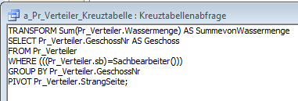
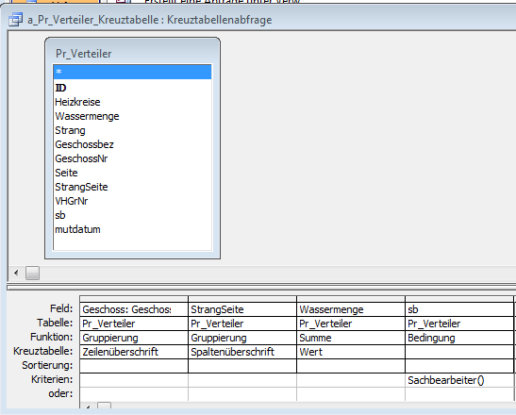

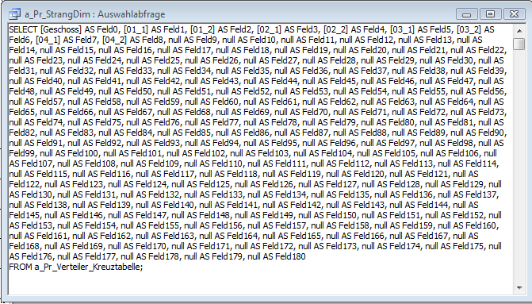

1.) Strangschema Hauptformularaufruf

Private Sub strangschema_Click()
'Strangschema per VBA erstellen 10.10.08 mj

On Error GoTo Err_strangschema_Click

sb = Forms!hauptmenü!Sachbearbeiter

Dim stDocName As String
Dim stDocNameorig As String
stDocNameorig = "b_Pr_Strangschema_orig"

Dim ctl As Control
tw = 567: ' Twips pro cm
'Masse in cm
strangabstand = 3.8

xstr = 3.25
xvL = 2.199: 'Verteiler links
xdimL = 3.199: 'Verteilerdim links
xlhvL = 3.12: 'Vorlauf horizontal links
xlhrL = 3.12: 'Rücklauf horizontal links
xsL = 3.65: 'Strang Links
xsR = 3.8: 'Strang Rechts
xdimR = 3.9: 'Verteilerdim rechts
xvR = 4.298: 'Verteiler rechts
xlhvR = 3.8: 'Vorlauf horizontal rechts
xlhrR = 3.65: 'Rücklauf horizontal rechts

xsdim = 3.898: 'Strangdimension (rechts)
xmstr = 2.704: 'Strangwassermenge (links)
xvhkL = 1.9: 'Anzahl Heizkreise Verteiler Links
xvhkR = 4.8: 'Anzahl Heizkreise Verteiler Links

nstr = DMax("[Strang]", "Pr_Verteiler")
Seitenzahl = Int(nstr / 6 + 0.9)

For snr = 1 To Seitenzahl

stDocName = "b_Pr_Strangschema_" & sb & snr

DoCmd.DeleteObject acReport, stDocName

DoCmd.CopyObject , stDocName, acReport, stDocNameorig

'stDocName = "b_Pr_Strangschema"
DoCmd.OpenReport stDocName, acViewDesign
'warten auf den Bericht
Do While Not Screen.ActiveReport.Name = stDocName
DoEvents
Loop

DoCmd.MoveSize 30, 20

If snr = 1 Then
'Unterbericht Heizgruppen
h = 3.1 * tw: b = 27.2 * tw: x = 0.11 * tw: Y = 1 * tw
Set ctl = CreateReportControl(stDocName, acSubform, acFooter, "", "", x, Y, b, h)
ctl.Name = "a_Pr_Heizgruppendaten"
ctl.SourceObject = "Report.bu_Pr_Heizgruppendaten"
CanGrow = True
ctl.BorderStyle = 1

End If

'SeitenNr
h = 0.423 * tw: b = 1 * tw: x = 18 * tw: Y = 0.2 * tw
Set ctl = CreateReportControl(stDocName, acTextBox, acPageFooter, "", "", x, Y, b, h)
ctl.Name = "snr"
ctl.ControlSource = "='" & snr & "'"
ctl.Visible = False
'Seitenzahl
h = 0.423 * tw: b = 1 * tw: x = 19 * tw: Y = 0.2 * tw
Set ctl = CreateReportControl(stDocName, acTextBox, acPageFooter, "", "", x, Y, b, h)
ctl.Name = "Seitenzahl"
ctl.ControlSource = "='" & Seitenzahl & "'"
ctl.Visible = False

For sn = 1 + (snr - 1) * 6 To snr * 6
spos = (sn - 1) - (snr - 1) * 6
'Linke Seite

'Strangnr
h = 0.476 * tw: b = 1 * tw: x = (xstr + strangabstand * spos) * tw: Y = 0 * tw
Set ctl = CreateReportControl(stDocName, acTextBox, acPageHeader, "", "", x, Y, b, h)
ctl.Name = "Strang" & sn
ctl.ControlSource = "='" & sn & "'"
ctl.BorderStyle = 0
ctl.TextAlign = 2
ctl.FontSize = 10
ctl.FontBold = True

'Heizgruppen Nr
h = 0.476 * tw: b = 1 * tw: x = (xstr + strangabstand * spos) * tw: Y = 0.1 * tw
Set ctl = CreateReportControl(stDocName, acTextBox, acFooter, "", "", x, Y, b, h)
ctl.Name = "HGr" & sn
ctl.ControlSource = "= Dlookup(""[VHGrNr]"",""Pr_Verteiler"",""Strang = " & sn & " and [sb] = '"" & sb & ""'"")"
ctl.BorderStyle = 0
ctl.TextAlign = 2
ctl.FontSize = 8
'ctl.FontBold = True

'Verteiler Strangnr Links
h = 0.476 * tw: b = 0.92 * tw: x = (xvL + strangabstand * spos) * tw: Y = 0.2 * tw
Set ctl = CreateReportControl(stDocName, acTextBox, acDetail, "", "", x, Y, b, h)
ctl.Name = "Verteiler" & sn & "_L"
ctl.ControlSource = "Feld" & sn + (sn - 1)
ctl.BorderStyle = 1
ctl.TextAlign = 2

'VerteilerDim Links
h = 0.317 * tw: b = 0.392 * tw: x = (xdimL + strangabstand * spos) * tw: Y = 0.279 * tw
Set ctl = CreateReportControl(stDocName, acTextBox, acDetail, "", "", x, Y, b, h)
ctl.Name = "Vdim" & sn & "_L"
ctl.ControlSource = "=iif([feld" & sn + (sn - 1) & "]>0,rohrdimension([feld" & sn + (sn - 1) & "]))"
ctl.BorderStyle = 0
ctl.TextAlign = 2
ctl.FontSize = 7

'Horizontale Linie Vorlauf Links
h = 0 * tw: b = 0.68 * tw: x = (xlhvL + strangabstand * spos) * tw: Y = 0.3 * tw
Set ctl = CreateReportControl(stDocName, acLine, acDetail, "", "", x, Y, b, h)
ctl.Name = "lhv" & sn & "_L"
ctl.BorderStyle = 1

'Horizontale Linie Rücklauf Links
h = 0 * tw: b = 0.53 * tw: x = (xlhrL + strangabstand * spos) * tw: Y = 0.612 * tw
Set ctl = CreateReportControl(stDocName, acLine, acDetail, "", "", x, Y, b, h)
ctl.Name = "lhr" & sn & "_L"
ctl.BorderStyle = 2

'Anzahl Heizkreise Links
h = 0.317 * tw: b = 0.75 * tw: x = (xvhkL + strangabstand * spos) * tw: Y = 0.698 * tw
Set ctl = CreateReportControl(stDocName, acTextBox, acDetail, "", "", x, Y, b, h)
ctl.Name = "hk" & sn & "_L"
strs = sn & ".1"
If sn < 10 Then strs = "0" & strs
ctl.ControlSource = "=""HK:"" & DLookup(""[Heizkreise]"", ""Pr_Verteiler"", ""[GeschossNr] = [Feld0] and [StrangSeite] = '" & strs & "' and [sb] = '"" & sb & ""'"")"
ctl.BorderStyle = 0
ctl.TextAlign = 2
ctl.FontSize = 7

'Rechte Seite

'Verteiler Rechts
h = 0.476 * tw: b = 0.92 * tw: x = (xvR + strangabstand * spos) * tw: Y = 0.2 * tw
Set ctl = CreateReportControl(stDocName, acTextBox, acDetail, "", "", x, Y, b, h)
ctl.Name = "Verteiler" & sn & "_R"
ctl.ControlSource = "Feld" & sn + (sn - 1) + 1
ctl.BorderStyle = 1
ctl.TextAlign = 2

'VerteilerDim Rechts
h = 0.317 * tw: b = 0.392 * tw: x = (xdimR + strangabstand * spos) * tw: Y = 0.279 * tw
Set ctl = CreateReportControl(stDocName, acTextBox, acDetail, "", "", x, Y, b, h)
ctl.Name = "Vdim" & sn & "_R"
ctl.ControlSource = "=iif([feld" & sn + (sn - 1) + 1 & "]>0,rohrdimension([feld" & sn + (sn - 1) + 1 & "]))"
ctl.BorderStyle = 0
ctl.TextAlign = 2
ctl.FontSize = 7

'Horizontale Linie Vorlauf Rechts
h = 0 * tw: b = 0.5 * tw: x = (xlhvR + strangabstand * spos) * tw: Y = 0.3 * tw
Set ctl = CreateReportControl(stDocName, acLine, acDetail, "", "", x, Y, b, h)
ctl.Name = "lhv" & sn & "_R"
ctl.BorderStyle = 1

'Horizontale Linie Rücklauf Rechts
h = 0 * tw: b = 0.648 * tw: x = (xlhrR + strangabstand * spos) * tw: Y = 0.612 * tw
Set ctl = CreateReportControl(stDocName, acLine, acDetail, "", "", x, Y, b, h)
ctl.Name = "lhr" & sn & "_R"
ctl.BorderStyle = 2

'Anzahl Heizkreise rechts
h = 0.317 * tw: b = 0.75 * tw: x = (xvhkR + strangabstand * spos) * tw: Y = 0.698 * tw
Set ctl = CreateReportControl(stDocName, acTextBox, acDetail, "", "", x, Y, b, h)
ctl.Name = "hk" & sn & "_R"
strs = sn & ".2"
If sn < 10 Then strs = "0" & strs
ctl.ControlSource = "=""HK:"" & DLookup(""[Heizkreise]"", ""Pr_Verteiler"", ""[GeschossNr] = [Feld0] and [StrangSeite] = '" & strs & "' and [sb] = '"" & sb & ""'"")"
ctl.BorderStyle = 0
ctl.TextAlign = 2
ctl.FontSize = 7

'Strang Links
h = 1.612 * tw: b = 0 * tw: x = (xsL + strangabstand * spos) * tw: Y = 0 * tw
Set ctl = CreateReportControl(stDocName, acLine, acDetail, "", "", x, Y, b, h)
ctl.Name = "str" & sn & "_L"
ctl.BorderStyle = 2

'Strang Rechts
h = 1.612 * tw: b = 0 * tw: x = (xsR + strangabstand * spos) * tw: Y = 0 * tw
Set ctl = CreateReportControl(stDocName, acLine, acDetail, "", "", x, Y, b, h)
ctl.Name = "str" & sn & "_R"
ctl.BorderStyle = 1

'Strangwassermenge (Links)
h = 0.476 * tw: b = 0.815 * tw: x = (xmstr + strangabstand * spos) * tw: Y = 0.799 * tw
Set ctl = CreateReportControl(stDocName, acTextBox, acDetail, "", "", x, Y, b, h)
ctl.Name = "mstr" & sn
ctl.ControlSource = "=[Feld" & sn + (sn - 1) & "] + " & "[Feld" & sn + (sn - 1) + 1 & "]"
ctl.BorderStyle = 0
ctl.TextAlign = 2
ctl.RunningSum = 1

'StrangDim (rechts)
h = 0.476 * tw: b = 0.788 * tw: x = (xsdim + strangabstand * spos) * tw: Y = 0.799 * tw
Set ctl = CreateReportControl(stDocName, acTextBox, acDetail, "", "", x, Y, b, h)
ctl.Name = "strdim" & sn
ctl.ControlSource = "=iif([mstr" & sn & "]>0,rohrdimension([mstr" & sn & "]))"
ctl.BorderStyle = 0
ctl.TextAlign = 2

If sn = nstr Then Exit For

Next sn
'DoCmd.OpenReport stDocName, acViewPreview

DoCmd.OpenReport stDocName, acViewNormal: 'Drucken
'warten auf den Bericht
Do While Not Screen.ActiveReport.Name = stDocName
DoEvents
Loop

DoCmd.Close acReport, stDocName, acSaveNo

'DoCmd.MoveSize 20, 20
Next snr

Exit_strangschema_Click:
Exit Sub

Err_strangschema_Click:

If Err = 7874 Then Resume Next

MsgBox Err.Description
Resume Exit_strangschema_Click

End Sub

2.) Bericht öffnen

Private Sub Report_Open(Cancel As Integer)

Call CreateReportQuery
End Sub

Private Sub ReportFooter_Format(Cancel As Integer, FormatCount As Integer)

End Sub

Sub CreateReportQuery()
On Error GoTo Err_CreateQuery
Dim db As DAO.Database
Dim rs As DAO.Recordset
Dim qdf As DAO.QueryDef
Dim fld As DAO.Field
Dim indexx As Integer
Dim FieldList As String
Dim strSQL As String
Dim i As Integer

Set db = CurrentDb
Set qdf = db.QueryDefs("a_Pr_Verteiler_Kreuztabelle")
indexx = 0
For Each fld In qdf.Fields
If fld.Type >= 1 And fld.Type <= 8 Or fld.Type = 10 Then
FieldList = FieldList & "[" & fld.Name & "] as Feld" & indexx & ", "
ReportLabel(indexx) = fld.Name
End If
indexx = indexx + 1
Next fld
For i = indexx To 180 '<<
FieldList = FieldList & "null as Feld" & i & ","
Next i
FieldList = Left(FieldList, Len(FieldList) - 1) '<<

strSQL = "Select " & FieldList & " From a_Pr_Verteiler_Kreuztabelle"
db.QueryDefs.Delete "a_Pr_StrangDim"
Set qdf = db.CreateQueryDef("a_Pr_StrangDim", strSQL)

Exit_CreateQuery:
Exit Sub

Err_CreateQuery:
If Err.Number = 3265 Then '*** if the error is the query is missing
Resume Next '*** then skip the delete line and resume on the next line
Else
MsgBox Err.Description '*** write out the error and exit the sub
Resume Exit_CreateQuery
End If
End Sub

3.) Bericht Detailbereich formatieren

Option Compare Database
Dim ReportLabel(180) As String '<<

'Strangschema zu Bodenheizungsberechnung 16.7.07 mj
Private Sub Detailbereich_Format(Cancel As Integer, FormatCount As Integer)
nstr = DMax("[Strang]", "Pr_Verteiler")

Dim i As Integer
For i = 1 To nstr
If Me("Verteiler" & (i) & "_L") = 0 Then
Me("Verteiler" & (i) & "_L").Visible = False
Me("lhv" & (i) & "_L").Visible = False
Me("lhr" & (i) & "_L").Visible = False
Me("Vdim" & (i) & "_L").Visible = False
Me("hk" & (i) & "_L").Visible = False
Else
Me("Verteiler" & (i) & "_L").Visible = True
Me("lhv" & (i) & "_L").Visible = True
Me("lhr" & (i) & "_L").Visible = True
Me("Vdim" & (i) & "_L").Visible = True
Me("hk" & (i) & "_L").Visible = True

End If
If Me("Verteiler" & (i) & "_R") = 0 Then
Me("Verteiler" & (i) & "_R").Visible = False
Me("lhv" & (i) & "_R").Visible = False
Me("lhr" & (i) & "_R").Visible = False
Me("Vdim" & (i) & "_R").Visible = False
Me("hk" & (i) & "_R").Visible = False
Else
Me("Verteiler" & (i) & "_R").Visible = True
Me("lhv" & (i) & "_R").Visible = True
Me("lhr" & (i) & "_R").Visible = True
Me("Vdim" & (i) & "_R").Visible = True
Me("hk" & (i) & "_R").Visible = True

End If

If Me("mstr" & (i)) = 0 Then
Me("mstr" & (i)).Visible = False
Me("strdim" & (i)).Visible = False
Me("str" & (i) & "_L").Visible = False
Me("str" & (i) & "_R").Visible = False
Else
Me("mstr" & (i)).Visible = True
Me("strdim" & (i)).Visible = True
Me("str" & (i) & "_L").Visible = True
Me("str" & (i) & "_R").Visible = True

End If

Next i

End Sub

