Eigene Schraffuren erstellen

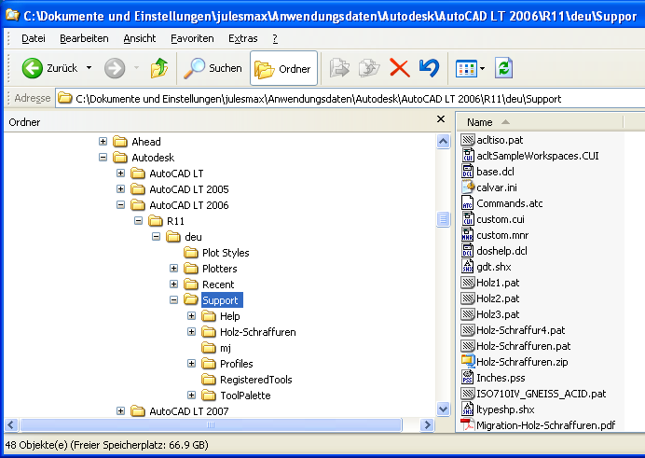

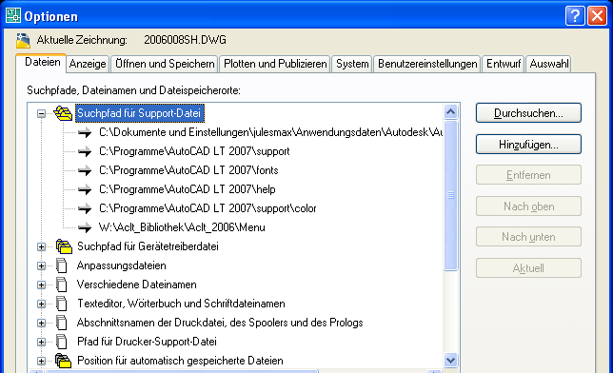

http://space.tin.it/edicola/lwcon/

; Holz-Schraffuren by www.neuWerk.biz

*Holz1,Holz1
0, .2,.05, 1,1, .05,-.95
90, .6,.4, 1,1, .1,-.9
45, .4,.3, .7071067812,.7071067812, .0707,-.2121,.0707,-.1414,.495,-.4243135623
45, .15,0, .7071067812,.7071067812, .07071,-.14142,.07071,-1.131373562
45, .5,.1, .7071067812,.7071067812, .07071,-1.343503562
45, .6,.05, .7071067812,.7071067812, .07071,-1.343503562
45, .45,.15, .7071067812,.7071067812, .07071,-1.343503562
45, .4,.2, .7071067812,.7071067812, .14142,-1.272793562
45, .65,.95, .7071067812,.7071067812, .14142,-1.272793562
45, .3,.25, .7071067812,.7071067812, .28284,-1.131373562
45, .25,.3, .7071067812,.7071067812, .28284,-1.131373562
45, .9,.6, .7071067812,.7071067812, .28284,-1.131373562
45, .2,.4, .7071067812,.7071067812, .212132,-1.202081562
45, 0,.55, .7071067812,.7071067812, .212132,-1.202081562
45, .1,.45, .7071067812,.7071067812, .212132,-1.202081562
45, .75,.75, .7071067812,.7071067812, .3535534,-1.060660162
45, .65,.8, .7071067812,.7071067812, .3535534,-1.060660162
45, .75,.55, .7071067812,.7071067812, .494974746,-.919238815
26.5650512, .3,.15, .894427191,-.4472135955, .11180339,-2.12426458
26.5650512, .5,.45, .894427191,-.4472135955, .11180339,-2.12426458
26.5650512, .45,.35, .894427191,-.4472135955, .11180339,-2.12426458
26.5650512, .25,.05, .894427191,-.4472135955, .2236068,-2.012461177
26.5650512, .45,.5, .894427191,-.4472135955, .335410196,-1.900657781
26.5650512, .35,.55, .894427191,-.4472135955, .447213595,-1.788854382
26.5650512, .25,.6, .894427191,-.4472135955, .447213595,-1.788854382
26.5650512, .1,.9, .894427191,-.4472135955, .447213595,-1.788854382
26.5650512, .1,.8, .894427191,-.4472135955, .559017,-1.677050977
26.5650512, .15,.7, .894427191,-.4472135955, .559017,-1.677050977
63.43494882, .5,.3, .894427191,.4472135955, .11180339,-2.12426458
63.43494882, .35,.2, .894427191,.4472135955, .11180339,-2.12426458
63.43494882, .2,.05, .894427191,.4472135955, .2236068,-2.012461177
63.43494882, .5,.2, .894427191,.4472135955, .2236068,-2.012461177
63.43494882, .1,0, .894427191,.4472135955, .335410196,-1.900657781
63.43494882, 0,0, .894427191,.4472135955, .447213595,-1.788854382
63.43494882, .9,.05, .894427191,.4472135955, .447213595,-1.788854382
63.43494882, .55,.15, .894427191,.4472135955, .447213595,-1.788854382
63.43494882, .75,.05, .894427191,.4472135955, .559017,-1.677050977
63.43494882, .65,.1, .894427191,.4472135955, .559017,-1.677050977

*Gewachsener-Boden LI, Gewachsener Boden links -^-^-^-
A,0.0001,[TRACK1,ltypeshp.shx,r=-45,s=.25,x=.4,y=.2],-0.0001,[TRACK1,ltypeshp.shx,r=-45,s=.25,x=.3,y=.2],-0.0001,[TRACK1,ltypeshp.shx,r=-45,s=.25,x=.2,y=.2],-0.0001,[TRACK1,ltypesh p.shx,r=-135,s=.1,x=0,y=.15],-0.0001,[TRACK1,ltypeshp.shx,r=-135,s=.1,x=-.05,y=.10],0.5
*Gewachsener-Boden RE, Gewachsener Boden rechts -^-^-^-
A,0.0001,[TRACK1,ltypeshp.shx,r=135,s=.25,x=.1,y=-.2],-0.0001,[TRACK1,ltypeshp.shx,r=135,s=.25,x=.2,y=-0.2],-0.0001,[TRACK1,ltypeshp.shx,r=135,s=.25,x=.3,y=-0.2],-0.0001,[TRACK1,lt ypeshp.shx,r=45,s=.1,x=.5,y=-0.15],-0.0001,[TRACK1,ltypeshp.shx,r=45,s=.1,x=.55,y=-0.10],0.5
